CA PRACTICAL EXPERIMENT GNUISM 8085

1. ADDITION OF TWO 8 BIT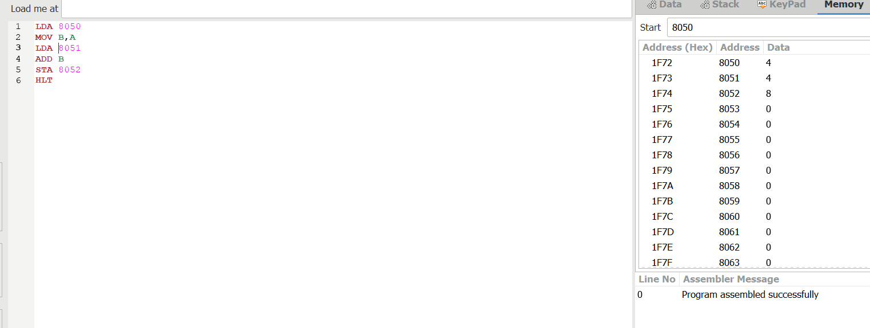

2.SUBTRACTION OF TWO 8 BIT
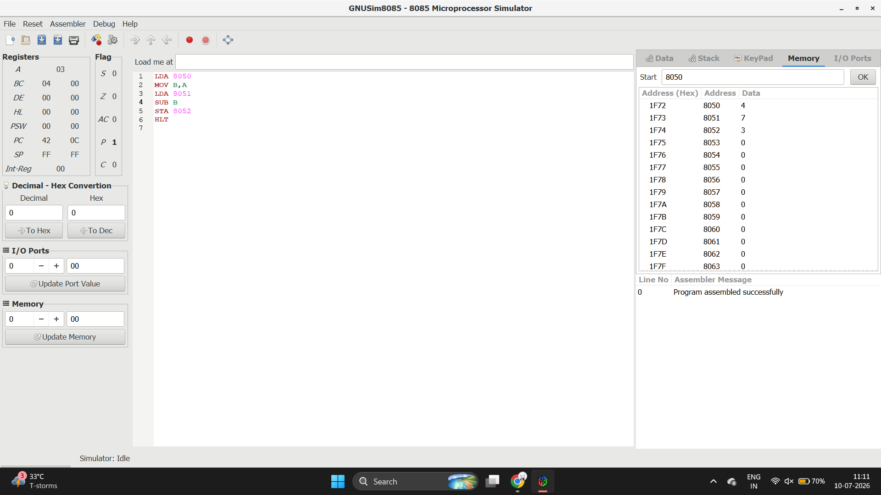
3.MULTIPLICATION OF TWO 8 BI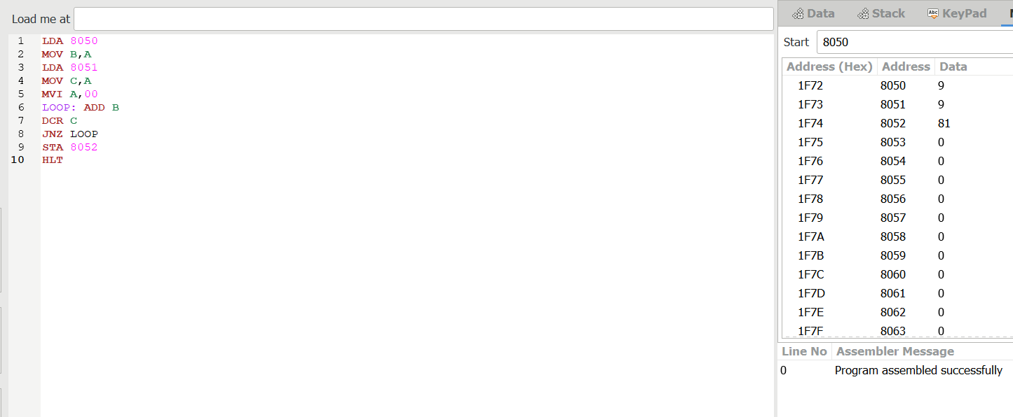
4.DIVISION OF TWO 8 BITS
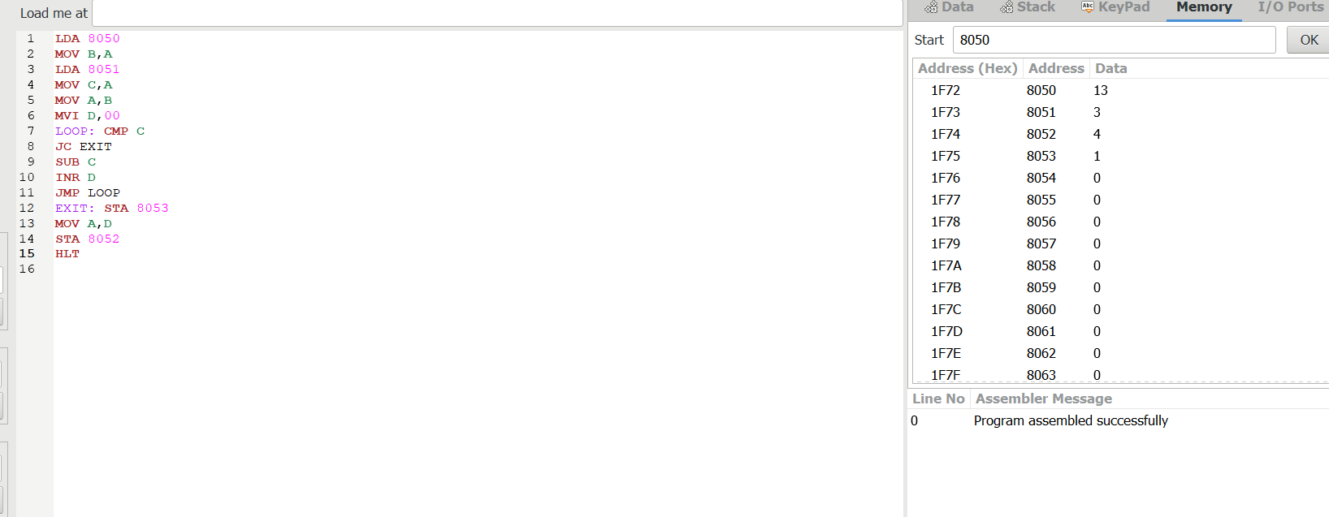

5.ADDITION OF TWO 16 BIT
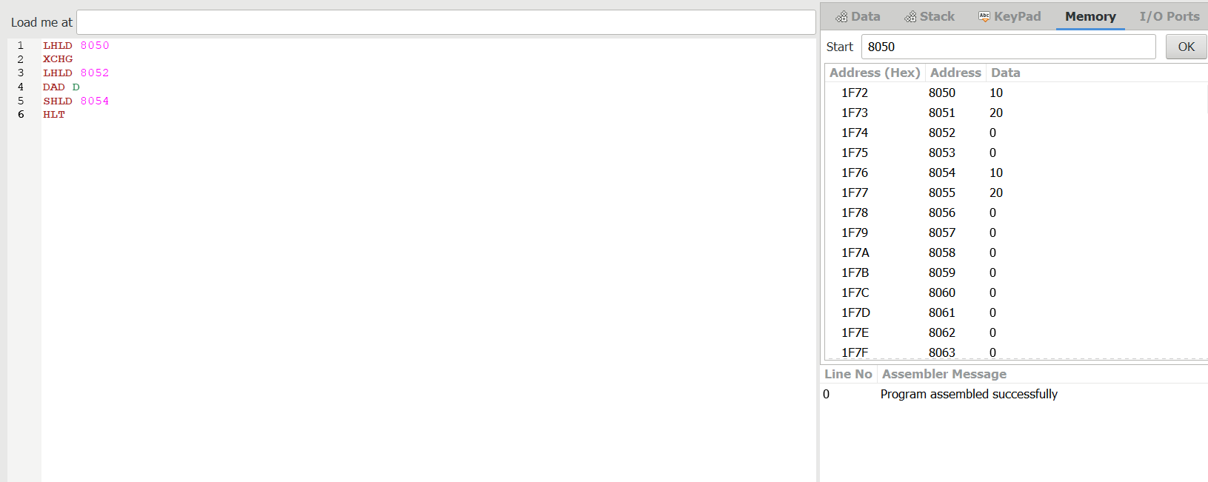
6.SUBTRACTION OF TWO 16 BIT NUMBERS
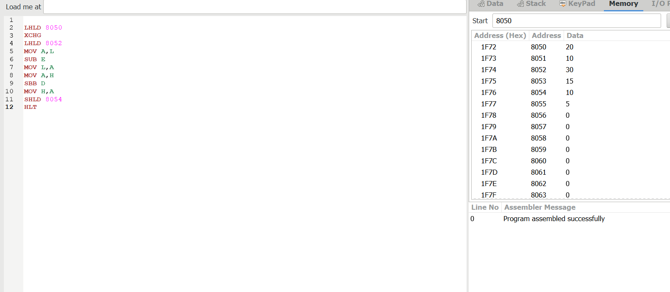
7.MULTIPLICATION OF TWO 16 BIT NUMBERS
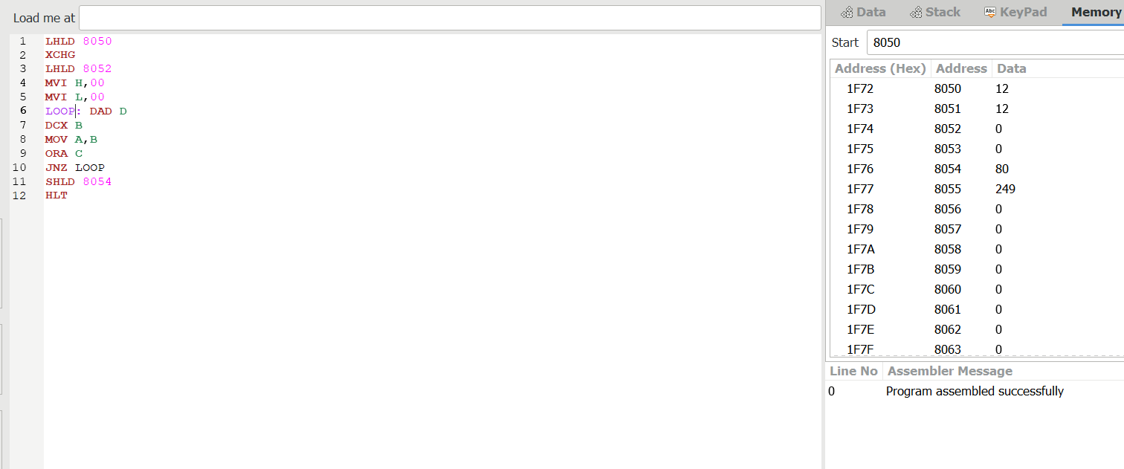
8.DIVISION OF TWO 16 BIT
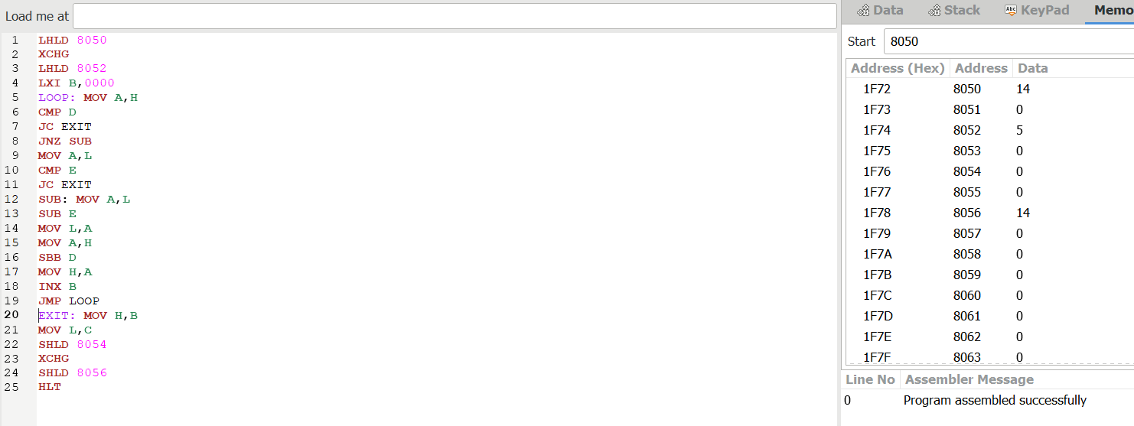
9.GREATEST OF TWO NUMBERS
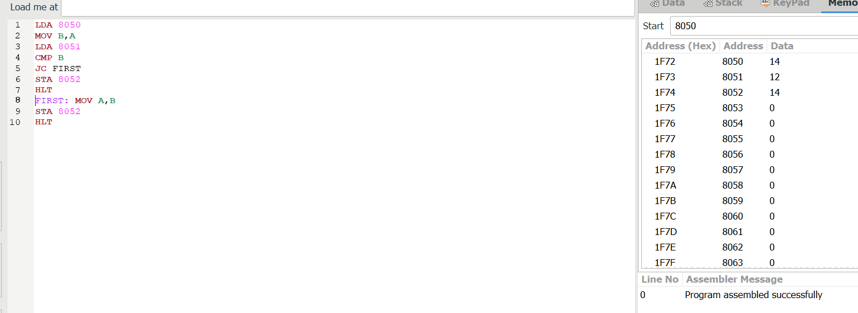
10.SMALLEST OF 2 NUMBERS
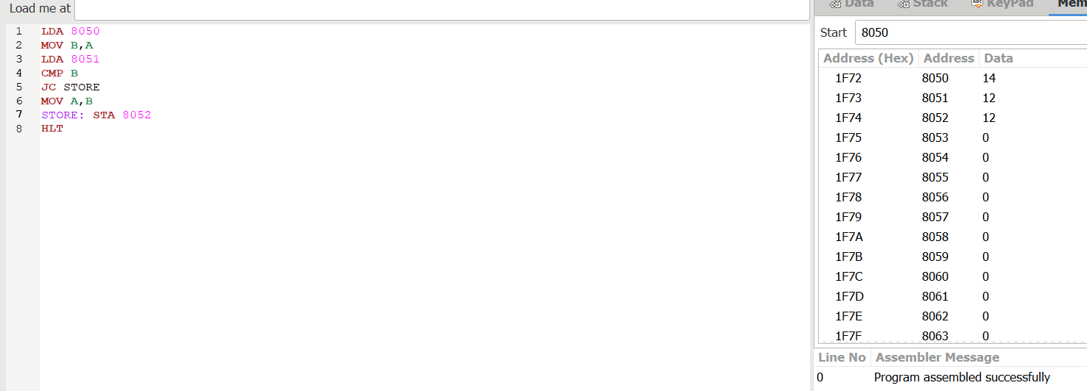
11. SWAPPING OF TWO NUMBERS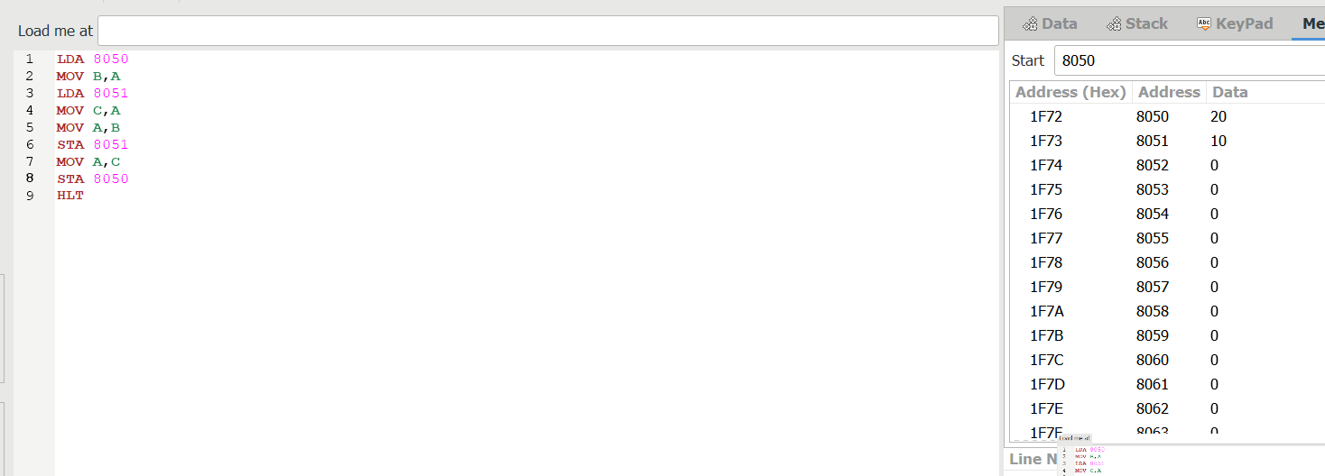
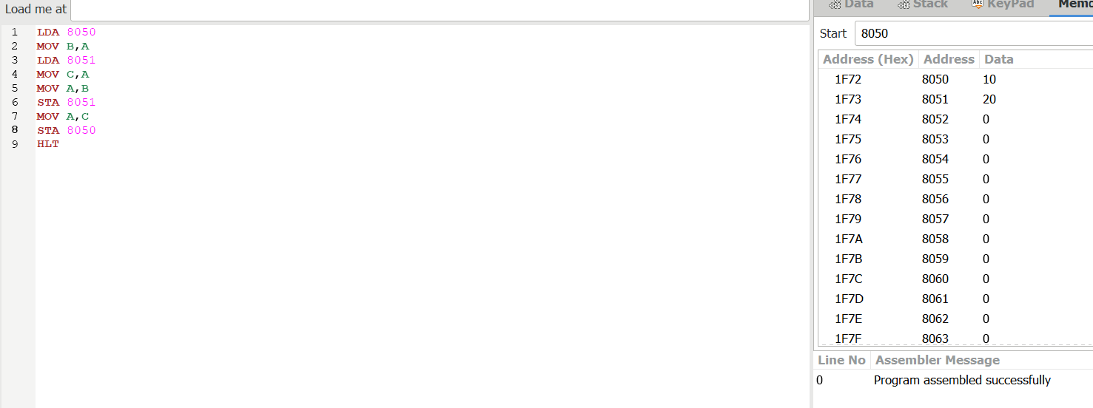
12. 1’S COMPLEMENT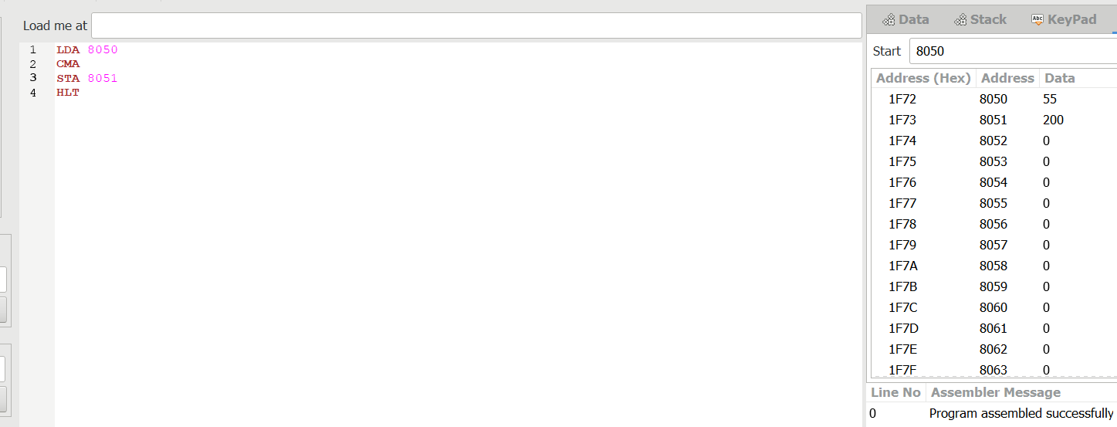
13. 2’S COMPLEMENT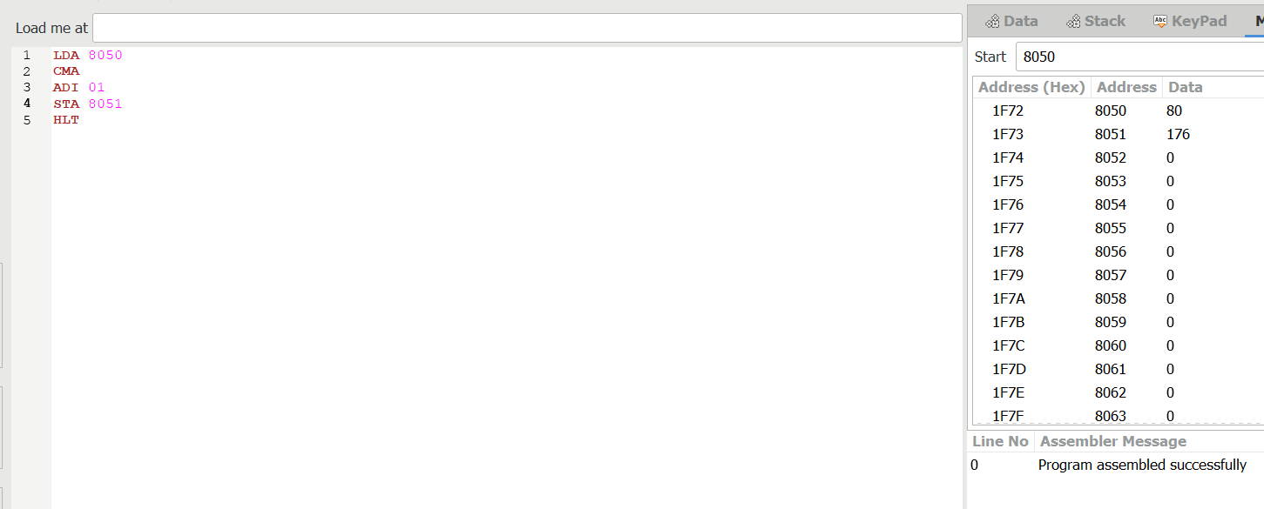
14. ODD OR EVEN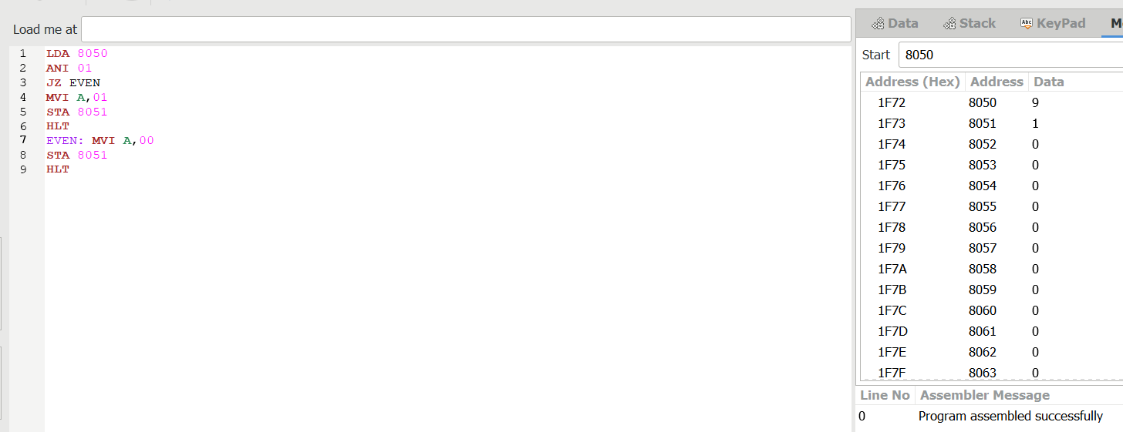
15. POSITIVE OR NEGATIVE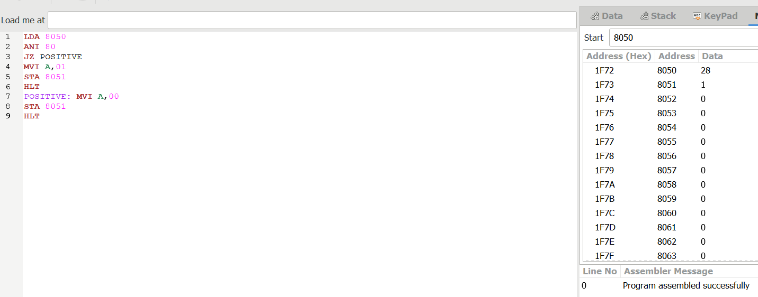
16. ASCENDING ORDER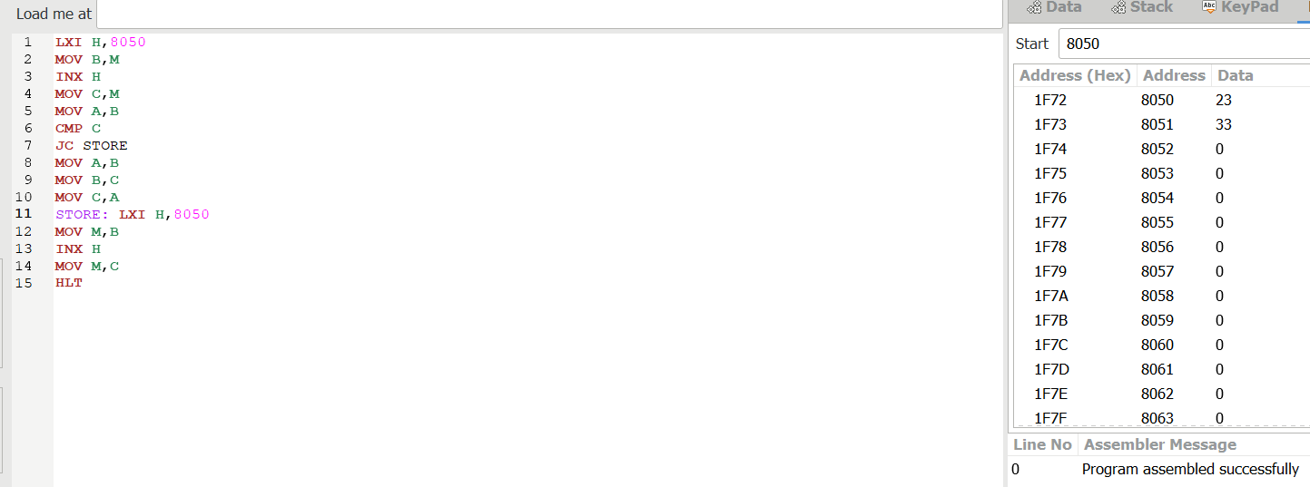

17.DESCENDING ORDER
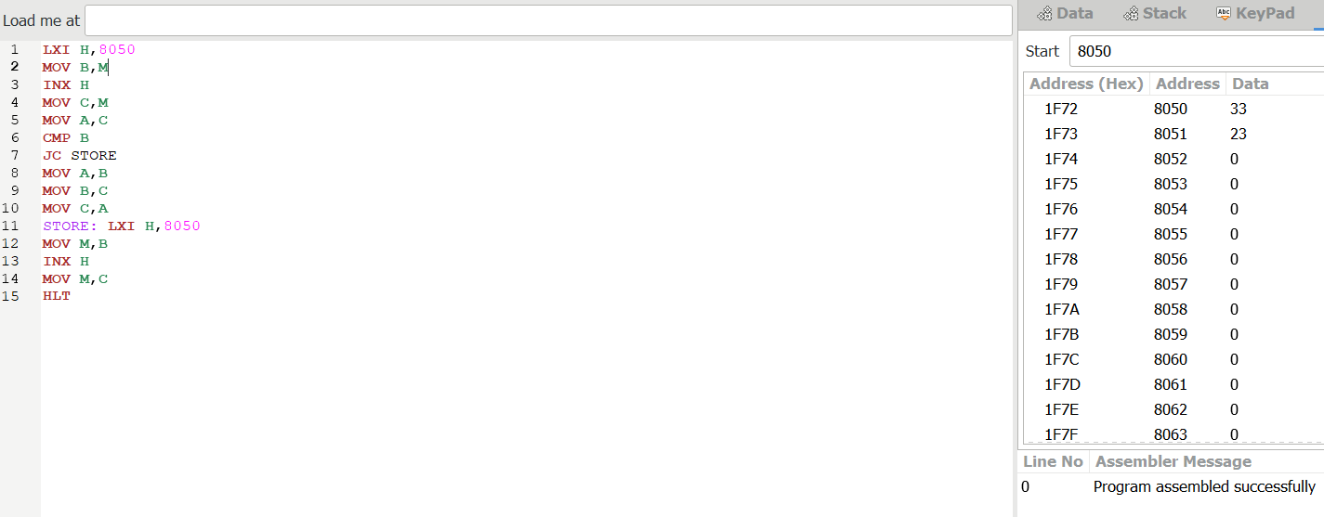
18.LARGEST NUMBER OF ARRAYS
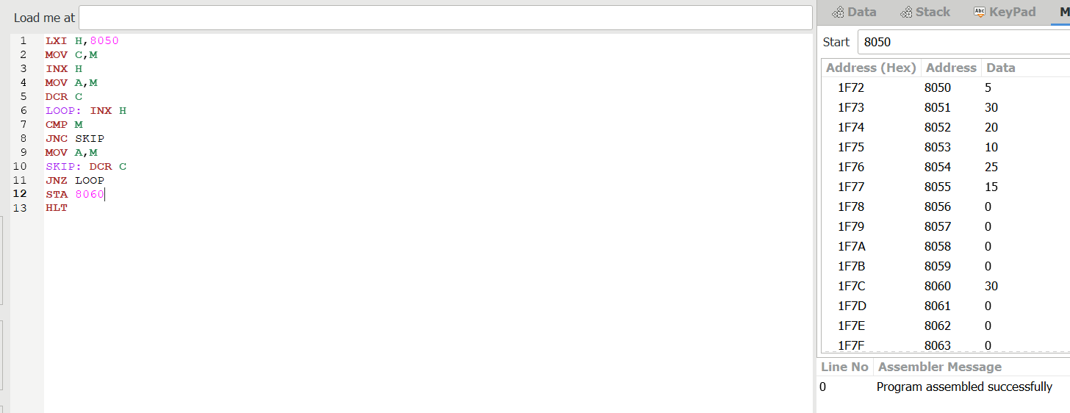
19.MINIMUM ARRAY
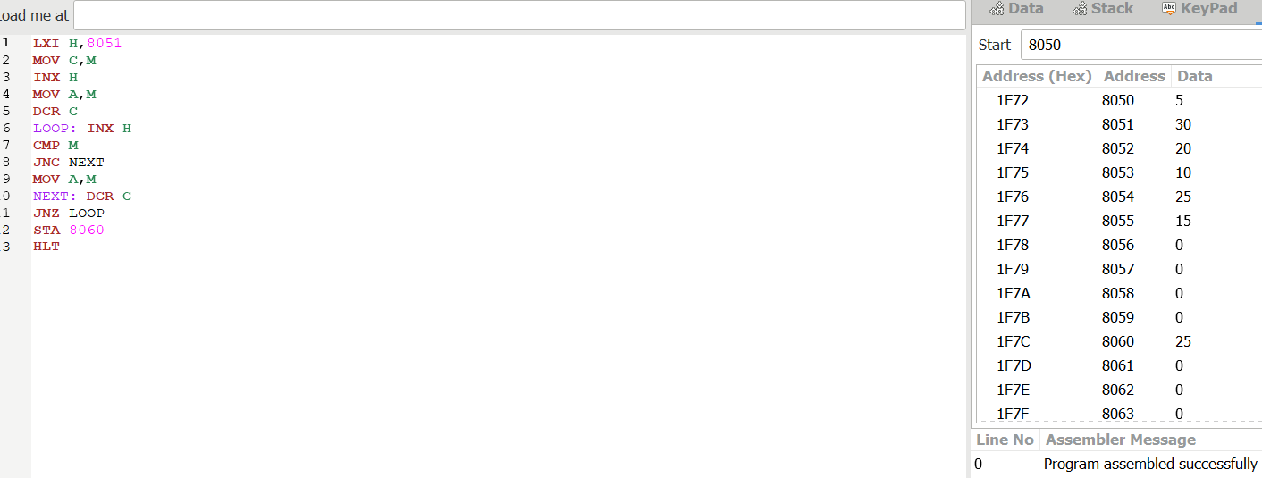
20.LCM
21.GCD

22. FACTORIAL OF NUMBER
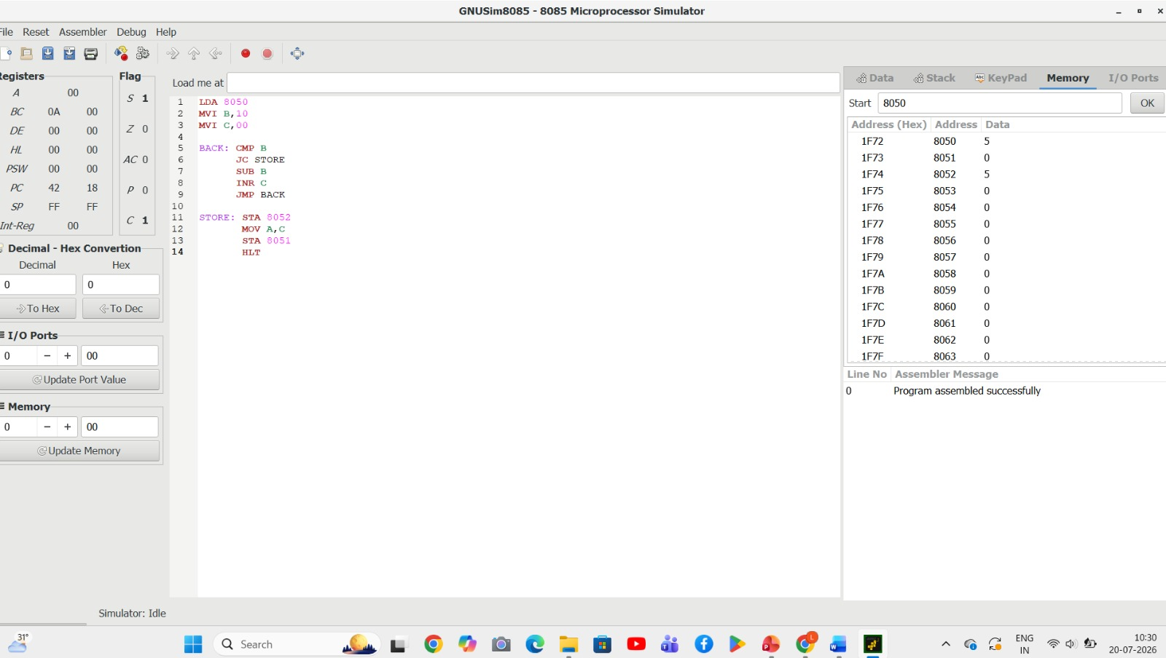
23. DECIMAL TO HEXADECIMAL


